Travel mart guide

Crew Assist

July/2014 For Internal Distribution Only
Contents
Introduction 2
How to Log In 3
How to change your password 4
Homepage 5
Hotel View 6
Hotel Exceptions 0-6 Days 6
Hotel Overflow 0-6 Days 7
How to take crewmembers out of Overflow 7
Vehicle View 9
Service Provider View 11
Service Provider Dashboard 11
Hotel Manifest 12
Vehicle Manifest 12
Pending 13
Search 14
Crewmember Information 15

Introduction

Last updated: July, 2014
Created by: Chiara van der Kwast

Travel Mart is a web based system created and managed by the Shipboard HR Strategy and Services of Royal Caribbean Cruises Ltd. This tool was designed to provide crewmember travel arrangements.
General information such as; E1identifications, names, and passport information will be visible to all users. Other information including; scheduled bookings with transportation vendors, hotel specialists, and the air team is displayed.
Save and print documents or itineraries, follow ongoing procedures by viewing remarks made by users and much more with Travel Mart.
For support or issues with the system, contact SHRSS_Support@rccl.com

How to Log In

Step 1: Go to Https://www.rclcrew.com
Step 2: Enter your Username and Password in the appropriate fields.
Step 3: Click on Log In
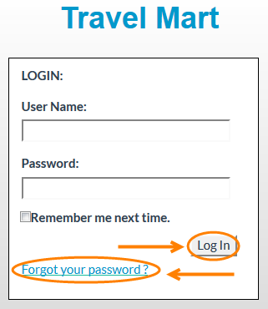
Note: If you are logging in for the first time, enter the username and password provided. Once you have logged in you will be prompted to change your password.
Forgot your password? Click on Forgot your password.
Enter your Username and you will receive and email with your password.
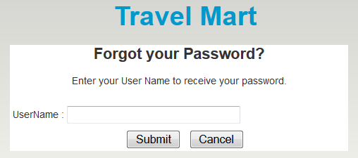

How to change your password

Step 1: At the top right corner of the screen, click on Change Password.
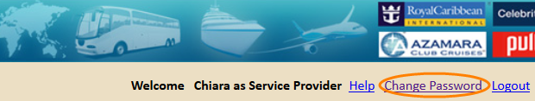
Step 2: In the field Password, enter your current password.
Step 3: In the field New password, enter the new password.
Step 4: Confirm your new password and click on Save.
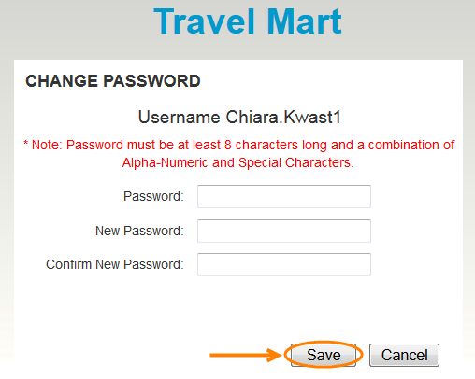

Note: Passwords are case sensitive and must be at least 8 characters long and a combination of Alpha-Numeric and Special Characters.

Homepage

Crewmembers detailed information will be visible to you, including Crew Schedule, Air Detail, Hotel Booking and Transportation Booking.
Step 1: Enter Employee ID and click on the Search button
Step 2: Select which out of the four services you would like to request. Hotel, Transportation, Service Provider or Meet and Greet.
Step 3: Select the needed check box
Step 4: Fill in the required blank fields
Step 5: Click Finish.
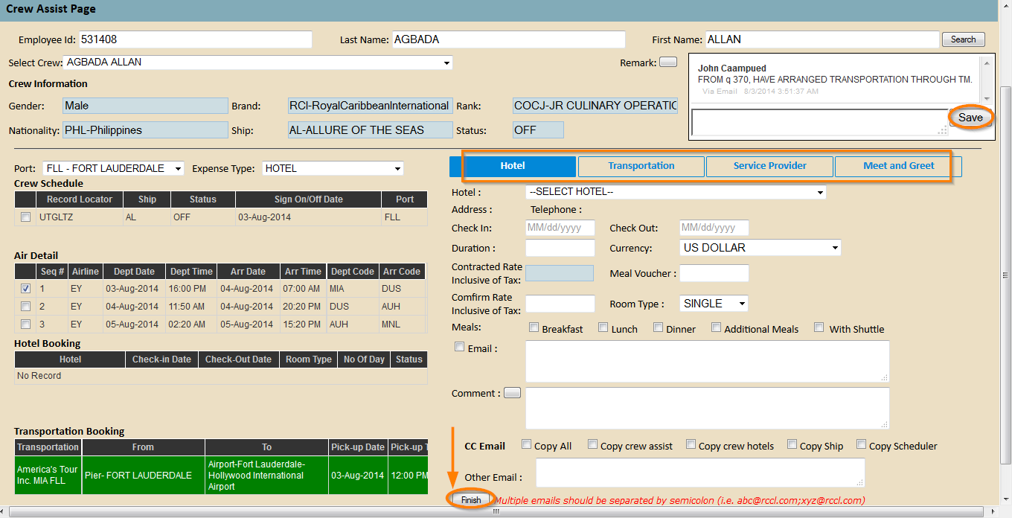
A pop-up will appear with a review of the request. Click Send if you wish to confirm request.
Note: Make sure to always check sign On/Off dates as bookings are made accordingly
All the bookings that appear in red are pending. All the bookings that appear in green are confirmed.

Hotel View

Hotel Exceptions 0-6 Days
Crewmembers are populated into this section when the travel related information in E1 and in Sabre does not match. Crew Assist or Hotel Specialist will then have to go through E1 and Sabre to detect the error and fix it.
- Click on Export Exception List if you wish to export the information into an excel spreadsheet.
- Click on View Removed Records. A list of crewmembers who were initially in the Exceptions List but who were removed will be visible to you.
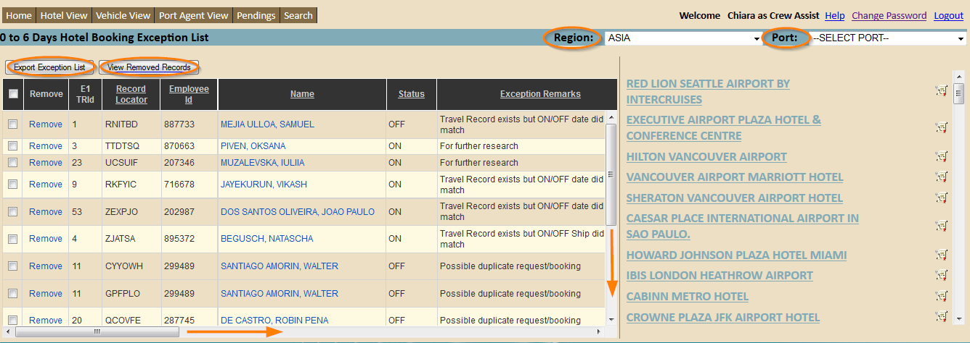
Once the error has been notified and fixed, the Crew Assist will be able to schedule a hotel room for this crewmember. Refer to How to take crewmembers out of Overflow for detailed information on how to schedule crewmember.

Hotel Overflow 0-6 Days
When a forecast is sent out to a hotel a certain amount of rooms will be blocked and reserved for crewmembers. Overflow 0-6 Days displays the crewmembers that do not fit in the reserved (blocked) rooms in the next 6 days.
The crewmembers that have been transferred to the Overflow List will appear. Information that will be available to you is as follows; Hotel name, City, E1 ID, Record Locator, Employee ID, Name, Status, Check-in Date, and so on.
- Click on Crewmember name (appears in blue) to access detailed information.
- Click on Export Overflow List if you wish to export the information it into an excel spreadsheet.
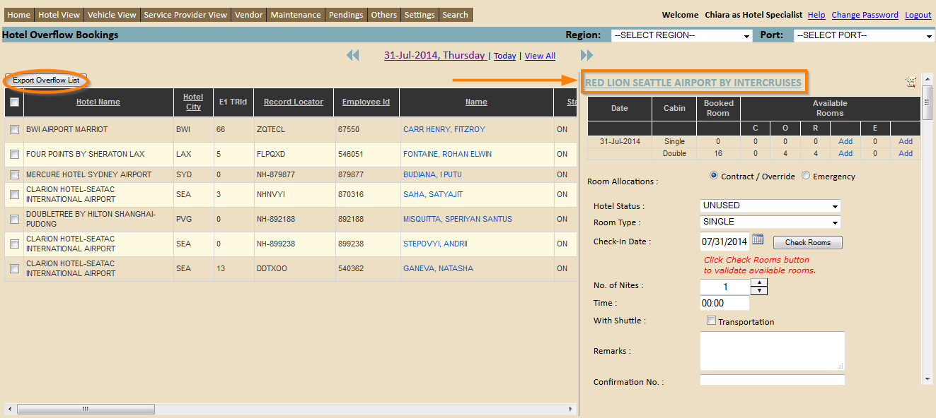

How to take crewmembers out of Overflow
In the information provided to you, you will see the amount of rooms booked
C = the rooms that have been blocked
O = the rooms that have been booked and are still available
R = remaining rooms – that are still available
(See example for clarification).
For example; 6 rooms were initially (C) Blocked and 3 rooms extra are needed due to Overflow. This means that 9 rooms in total are needed. Now 7 rooms have already been Booked (Booked Rooms) so in fact 2 rooms will be (R) Remaining that are available.
Note: You will have the possibility of adding on to this amount of rooms needed by clicking on add. If you wish to delete a room that was needed click on add and use negative numbering. (For example: -3)
Step 1: Select the check box of an overflow crewmember that is supposed to stay in the hotel you have clicked on
Step 2: Fill in the required field
Note: Contact hotel by email or via the phone to make the necessary booking for this crewmember.
Step 4: Click on SAVE
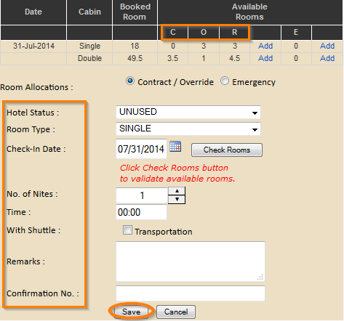
This overflow crewmember has now been booked and will automatically be transferred out of the overflow list.
Note: Make sure to always check sign On/Off dates as bookings are made accordingly

Vehicle View

View data by date
Step 1: Click on the date displayed at the top of the page. A calendar will appear. Or click on the arrows to go back and forth.
Step 2: Select the date you wish to view. A new screen will display details of sign on and off crewmembers for that selected day.
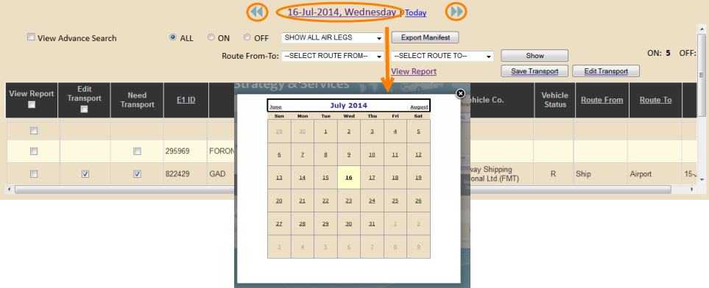
Step 3: Select All, On or OFF
On = Crewmembers embarking a vessel
OFF = Crewmembers disembarking a vessel
Potential OFF = OFFs that are not yet confirmed by the vessel.
Step 4: Select Route and City, From and To by clicking on the drop down box
Step 5: Select a Vehicle Company
Step 6: Click on Search
Click on Export if you wish to export the information into an excel spreadsheet
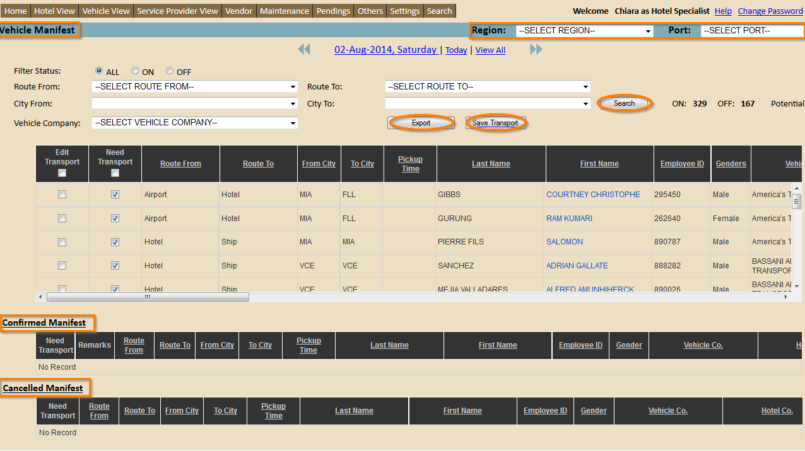
- Select the Need Transport check boxes for those required to have transportation
- Click on Save Transport
- Select the Edit Transportation check boxes for those that need arrangement changes to be made

- Click on Save Transport
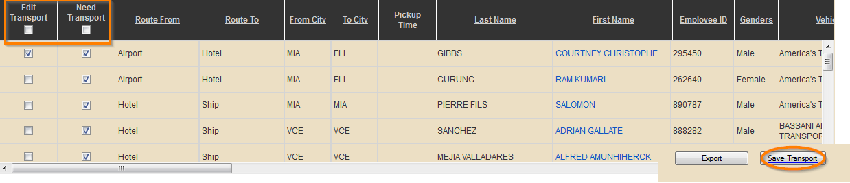
- A pop-up will appear. Fill in all required fields and click Confirm.
An email will be sent to the vendor.

Service Provider View

Service Provider Dashboard
Step 2: Filter information by: Seaport, Service Provider and/or Number of Days.
Step 3: Click on a Service Provider
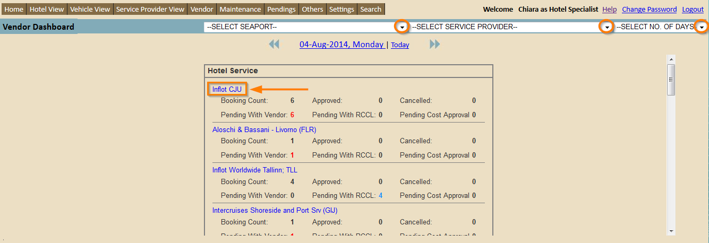
You will be redirected to the following page.
- Filter information by: Service Provider, Status and/or Number of Days
- Click on Export if you wish to export the information into an excel spreadsheet
- Click on Edit Amount if you wish to negotiate with vendor
- Select all, multiple or one check box in the confirm section and click on Approve. This is only possible when pending with RCCL and you wish to approve request.
- Select all, multiple or one check box in the cancel section and click on Cancel. This is if you wish to cancel request.
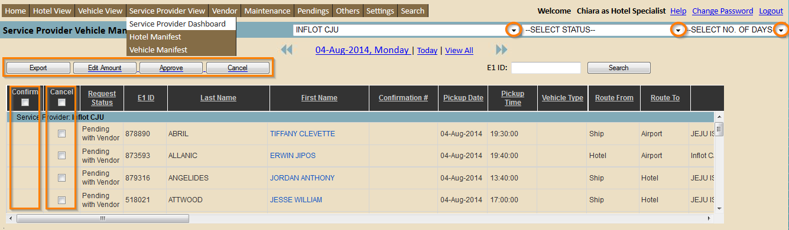
Note: Narrow down search by entering the E1 ID and clicking on Search

Hotel Manifest
- Filter information by: Service Provider, Status and/or Number of Days.
- Click on Export if you wish to export the information into an excel spreadsheet
- Click on Edit Amount if you wish to negotiate with vendor
- Select all, multiple or one check box in the Select section and click on Approve. This is only possible when pending with RCCL and you wish to approve request.
- Select all, multiple or one check box in the Cancel section and click on Cancel. This is if you wish to cancel request.
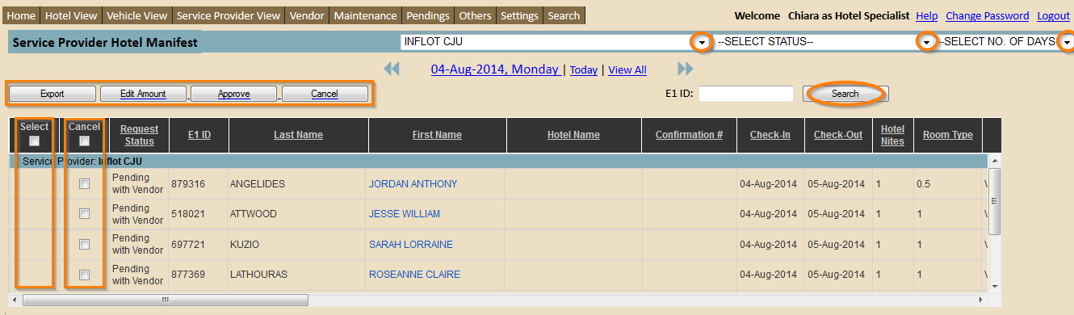

Vehicle Manifest
- Filter information by: Service Provider, Status and/or Number of Days.
- Click on Export if you wish to export the information into an excel spreadsheet
- Click on Edit Amount if you wish to negotiate with vendor
- Select all, multiple or one check box in the Confirm section and click on Approve. This is only possible when pending with RCCL and you wish to approve request.
- Select all, multiple or one check box in the Cancel section and click on Cancel. This is if you wish to cancel request.
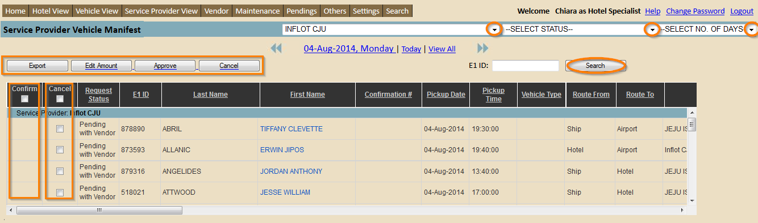

Pending

View data by date
Step 1: Click on the date displayed at the top of the page. A calendar will appear. Or click on the arrows to go back and forth.
Step 2: Select the date you wish to view. A new screen will display details of sign on and off crewmembers for that selected day.
- Filter information and click on Search
- Click on Export if you wish to export the information into an excel spreadsheet
- Click on Save if you wish confirm request
- Click on Crewmember Name (appears in blue) and you will be redirected to the crew assist page. Refer to Crew Assist Homepage on how to schedule bookings.
- Click on Email (appears in blue) if you wish to resend the booking confirmation that was sent out
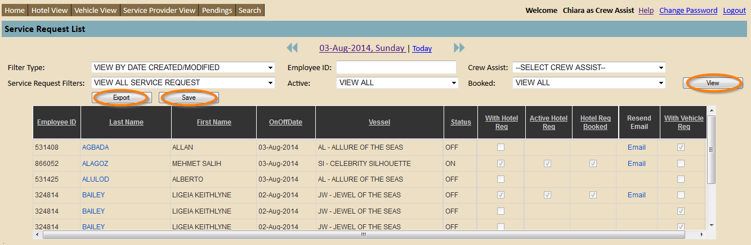

Search
Step 1: Filter crewmember by entering the Employee ID, Last Name, First Name, and/or Record Locator. You can also filter by ship. Enter Code and/or name of ship.
Step 2: Click on Search.
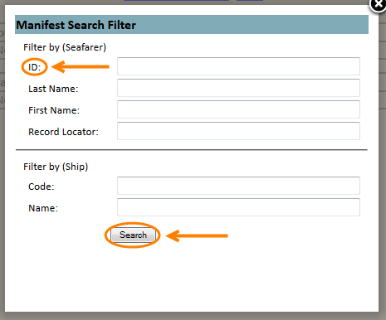
Note: Filtering by Employee ID would be the easiest way to find the correct data seeing as names can have similarities.

Crewmember Information

Once you have found the correct data you can start reviewing the information visible to you.
On the first page you will be able to view future travel arrangements of the crewmember.
- Scroll back and forth to view all the information provided to you. The information that will be displayed is as follows; E1 Travel number, E1 ID, Name, On/Off Date, Crew Status, Reason Code, Port, Brand, Rank, Air Status, Vehicle Status, Hotel Status, Record Locator, Origin-Destination, Meet & Greet, Service Provider, Hotel vender, and Remarks.

Air, Vehicle, and Hotel status refers to if this service has been scheduled for this specific crew member.
This sign indicates that this service has not been scheduled for this specific crewmember.
This sign indicates that this service has been scheduled for this specific crewmember.
- Select View All on the top left of the page to view past travel arrangements. The travel history will be shown in alphabetical order by ship not by date.
- Click on crewmember name. You will be redirected to a page with more detailed information about the crewmember and travel arrangements.
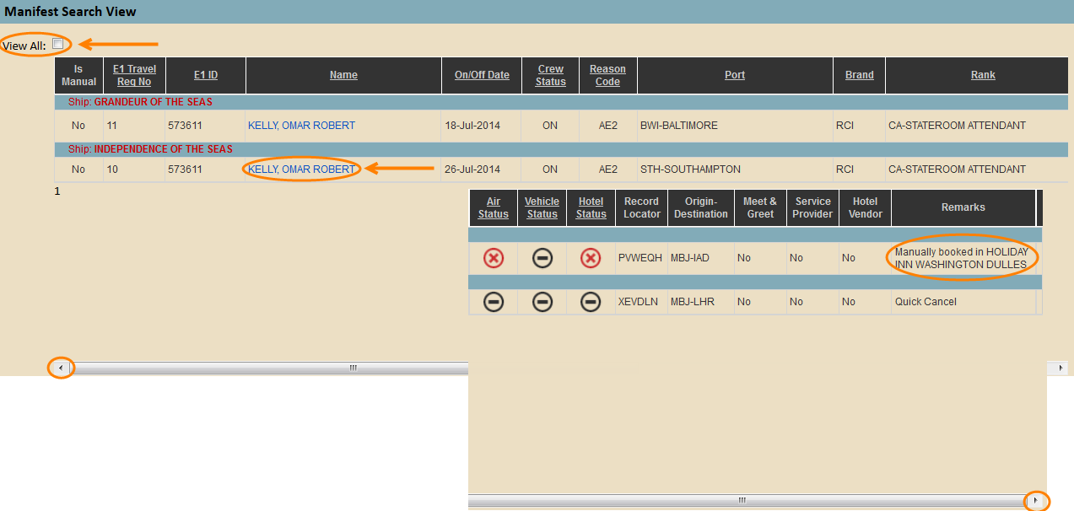
Note: Remarks displayed on the right side of the column are automatically plugged in when changes are made.

In box 1 you will be able to view: E1 ID, Name, Nationality, Gender, Brand, Ship, Rank, Reason Code, Status, Signing ON Date, Signing OFF Date, and Origin/destination.
In box 2 you will be able to posts a remark. See the following steps for further detail.
All other information is as follows: Air Travel, Vehicle, and Port information.
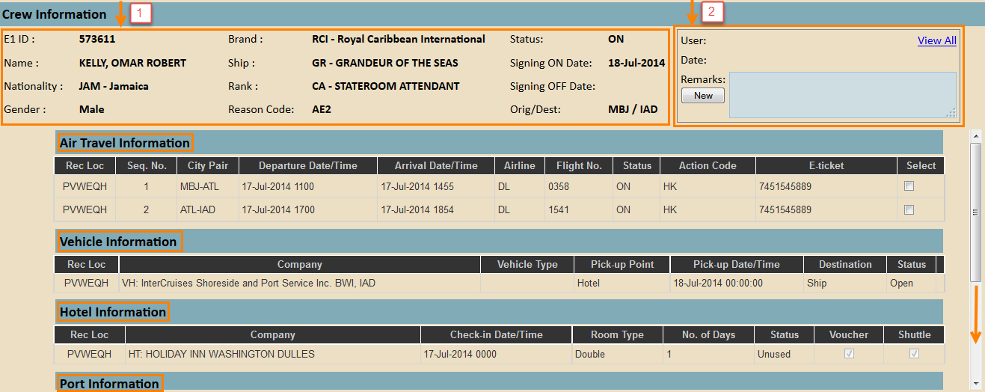

- Post a remark regarding a travel related situation by clicking on New in the comment box on the top right.
- Enter in comment and click on Save or Cancel.
- Click on View All if you wish to view previous remarks made by Crew Assist and/or the Finance Team.
